
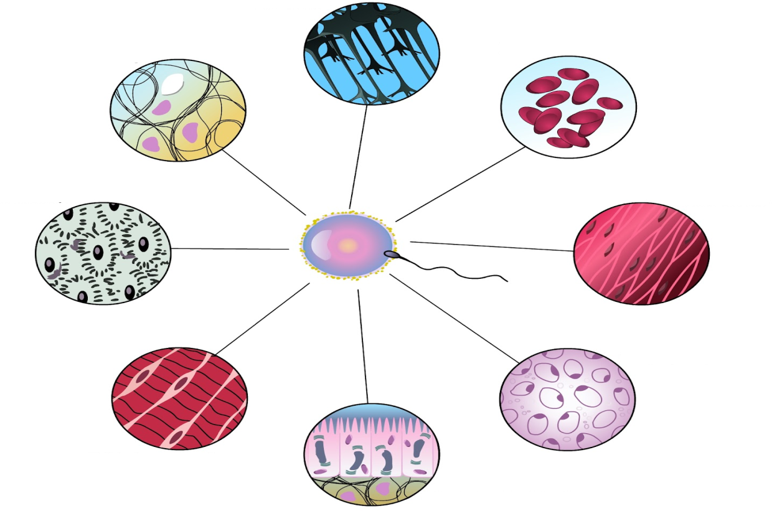
Virtual University of Pakistan
Laboratory Manual for Cell Biology (BIO201)
Contents

S. No. | Practical | P. No.
1 | Microscopy | 3
2 | Staining techniques | 6
3 | Study of Prokaryotic Cell | 8
4 | Study of Eukaryotic Cell | 13
5 | Study Plant cell | 15
6 | Study Animal cell | 17
7 | Cell structure in Staminal hair of tradescantia | 20
8 | Study of different types of plastids | 21
9 | Study of cellular reproduction | 24
10 | Study of Mitosis (Prepared slides) | 27
11 | Study of Meiosis (Prepared slides) | 31
12 | Mitosis: smear/squash preparation of onion roots | 34

Practical No: 1 Microscopy

Microscope
A microscope (from the Ancient Greek: μικρός, mikrós, small and σκοπεῖν, skopeîn, to look or see) is an instrument used to see objects that are too small to be seen by the naked eye. Microscopy is the science of investigating small objects and structures using such an instrument. Microorganisms are so small that they cannot be seen by naked eye. The optical instrument that magnifies the image of these organisms and enables us to view their morphological features is a microscope. Antony van Leeuwenhoek is often considered as the father of microscopy.
Most bacteria measure in the range of 0.5 to 4 µm. Mycoplasma and Coxiella are the shortest among bacteria and Spirochetes the longest. Viruses are ultramicroscopic structures; they can’t be seen by compound microscopes. They can be visualized by electron microscopes and their measurements are in nm (nanometer).
Various types of microscopes are
There are several different types of microscopes used in light microscopy, and the four most popular types are Compound, Stereo, Digital and the Pocket or handheld microscopes. Some types are best suited for biological applications, where others are best for classroom or personal hobby use.
- Simple microscope
- Compound microscope
- Dark ground microscope
- Phase contrast microscope
- Fluorescent microscope
- Interference microscope
- Electron microscope
- Atomic Force microscope
- Polarization microscope

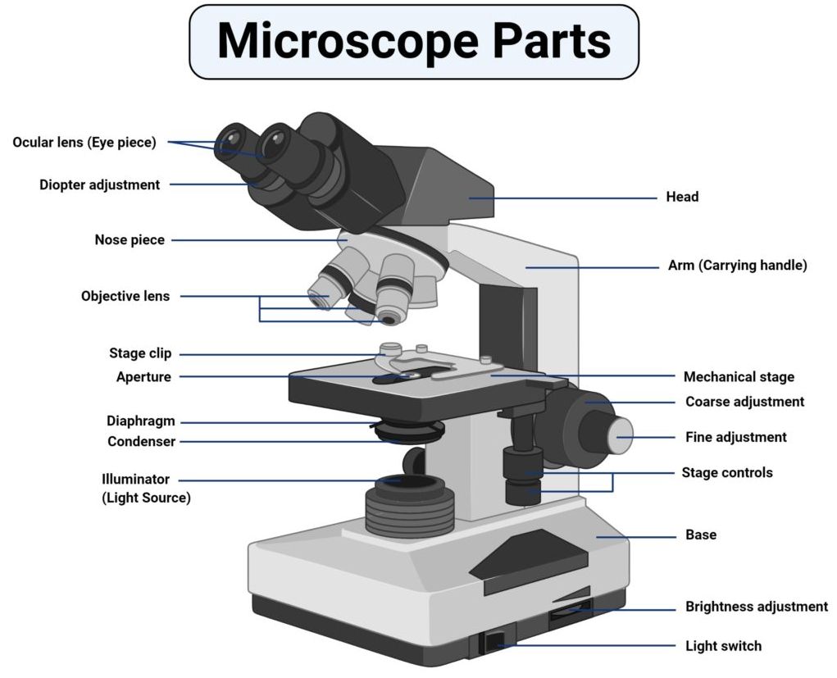
Fig 1.1: Detail of Microscope

A microscope is commonly used in a microbiological study of organisms. The basic modern microscope found in schools, hospitals, and research centers is a compound microscope which has a series of lenses to collect and focus the light transmitted through the specimen. The various parts of a microscope with their associated function are mentioned below.
Tube:
Tube or the body tube, connects the eyepiece to the objective lenses.
Eyepiece or ocular lens:
Eyepiece is the lens, present at the top and is used to see the objects under study. Eyepiece lens contains a magnification of 10X or 15X.
Resolving nosepiece:
It is also known as the Turret. Resolving nosepiece has holders for the different objective lenses.
It allows the rotation of the lenses while viewing.
Objective lenses:
Generally, three or four objective lenses are found on a microscope, with ranges of 10X, 40X, 100X powers. Lenses are color coded, the shortest lens is of the lowest power, and the longest lens is high power lens.
Diaphragm:
Diaphragm helps in controlling the amount of light that is passing through the opening of the stage. It is helpful in the adjustment of the control of light that enters.
Coarse adjustment knob:
Used for focus on scanning. Usually the low power lens is used enabling the movement of the tube.
Fine adjustment knob:
Used for focus on oil. It moves the body tube for focusing the high power lens.
Arm:
It supports the tube of the microscope and connects to the base of the microscope.
Stage:
A flat platform used for placing the slides under observation.
Stage clip:
Stage clips hold the slides in proper place.
Condenser:
The main function of condenser lens is focusing the light on the specimen under observation. It gives a sharp image.
Base:
It provides basal support for the microscope.
Power switch:
It turns the illumination on or off.
Proper usage and handling the microscope:
Microscope is a delicate instrument that must be handled with care. All kinds of mechanical shocks must be avoided. The microscope must be lifted by holding its arm in one hard and supporting the base of the microscope with the palm of the other hand. The microscope must be kept in dust free environment. The oil must be wiped clean using a soft tissue paper. After usage the slide must be removed and cleaned before returning to its original place.

Practical No: 2 Staining techniques

Staining
A technique that is used to define and examine different types of microbes
Types of staining techniques
- Simple stain techniques
Simple staining is performed with basic dyes such as crystal violet or methylene blue.
- Differential stain techniques
Differential stain technique distinguishes two kinds of organisms. There are two types of this technique; one is Gram stain technique while other is acid fast technique.
Gram stain technique
A most commonly used technique for study of microbes like bacteria.
Principle
This technique separates bacteria into two groups, Gram‐positive bacteria and Gram‐negative bacteria.
Materials
- Clean glass slides
- Inoculating loop
- Bunsen burner
- Bibulous paper
- Microscope
- Lens paper and lens cleaner
- Immersion oil
- Distilled water
- 18 to 24 hour cultures of organisms
Reagents
Primary Stain | Crystal Violet
Mordant | Grams Iodine
Decolourizer | Ethyl Alcohol
Secondary Stain | Safranin
Procedure
- Smear preparation
A small sample of microorganisms is placed on a slide and permitted to air dry. The smear is heat fixed by quickly passing it over a flame. Heat fixing kills the organisms, makes them adhere to the slide, and permits them to accept.
- Primary stain
Apply crystal violet as primary stain
- Mordant
Use iodine as a mordant
- Decolourizer
Wash with ethyl alcohol that acts as a decolourizing agent. Gram‐positive bacteria retain the crystal‐violet iodine stain; however, the Gram‐negative bacteria lose the stain.
- Secondary stain
The Gram‐negative bacteria subsequently stain with the Safranin dye, the counterstain. These bacteria appear red under the oil‐immersion lens, while Gram‐positive bacteria appear blue or purple, reflecting the crystal violet retained during the washing step.

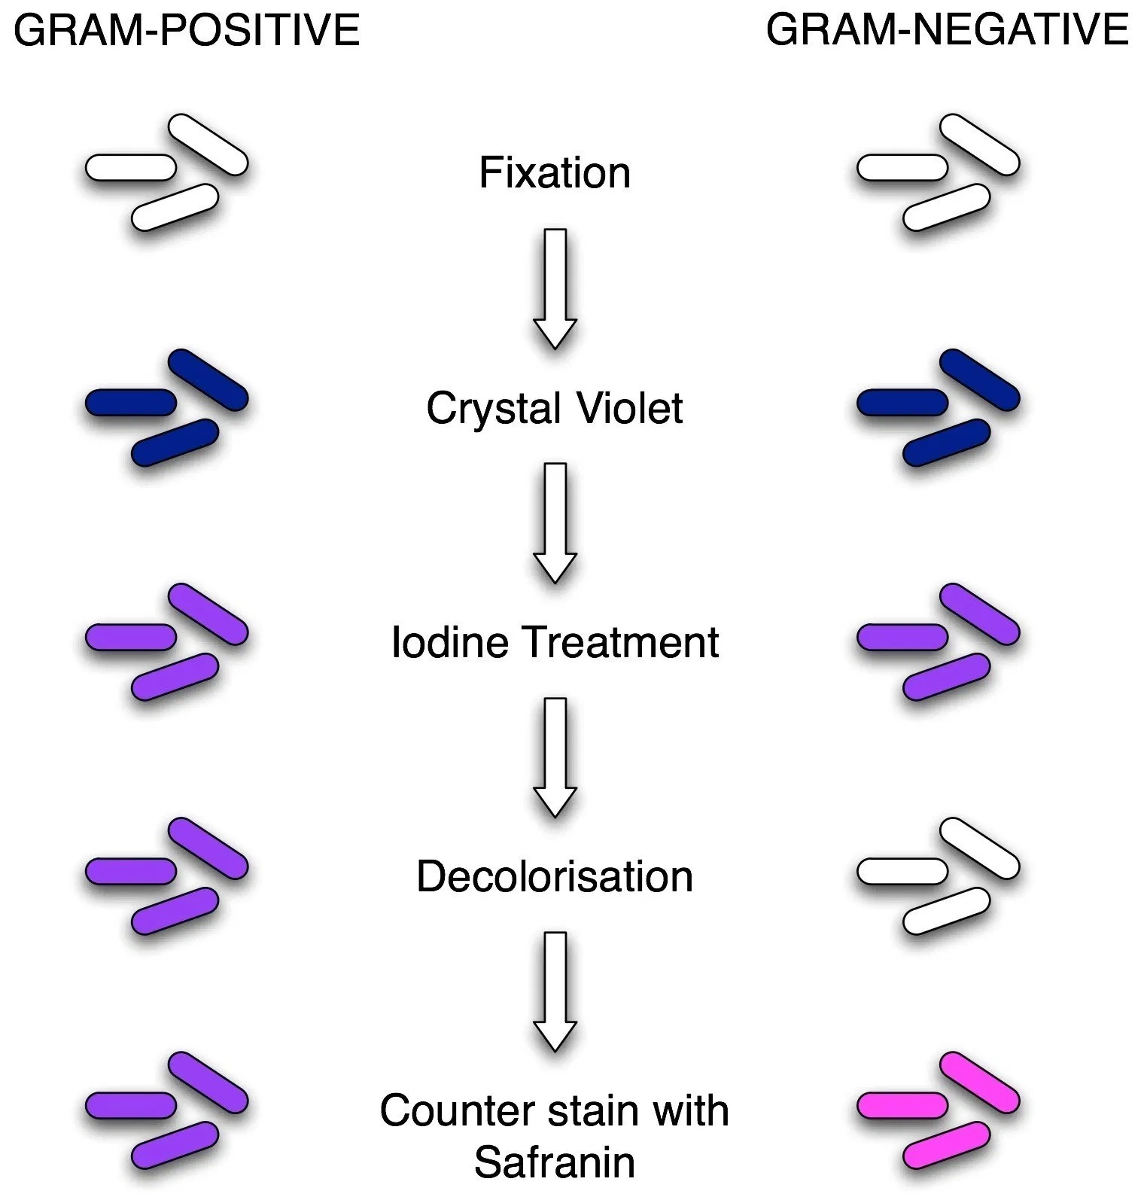

Fig 2.1: Comparsion between gram positive and negative

Practical No: 3 Study of Prokaryotic cell

Principle
Prokaryotic cells are cells that do not have a true nucleus or membrane-bound organelles. Organisms within the domains Bacteria and Archaea have prokaryotic cells, while other forms of life are eukaryotic. However, organisms with prokaryotic cells are abundant and make up much of Earth’s biomass.
Objective
To study the specimen preparation step for a prokaryotic cell
To study the procedure of simple staining
Light microscopic examination of the cells requires fixing and staining of the cells prior to observation. These processes can increase the visibility and clarity of the cell under study.
Fixation
Fixation is the process by which internal and external structures of a cell are preserved. Cell should not undergo any change in its state during the process of staining and observation. To ensure this, it is necessary to toughen the cell and to stop any chemical reaction that might take place within the cell that is the cell should be fixed at its current state. Based on the method of fixation a microscopic slide might be used for longer or shorter period of time or used as temporary or permanent slides. Even when great care is taken to fix the cells properly sometimes artifacts might be produced. Fixation step must therefore be standardized. The procedure for fixation varies with the fixative and the type of tissue or cell under study.
There are 2 types of fixation
Heat fixation: This helps to preserve the overall morphology of a cell. This is commonly used in smear preparation and preparation of temporary slides.
Chemical fixation: In this method chemicals are used to preserve fine cellular substructures and morphology of more delicate microorganism. The chemicals used for fixation are known as fixative. A fixative might either stop any internal biochemical processes that take place within a cell, protect the cell from external damage or might increase the mechanical strength and stability. Chemical fixatives are commonly used in preparation of permanent slides.
Staining
The sample under examination is called the specimen. Specimen preparation is an important step in light microscopic examination of a given sample. Light microscopy can reveal better details if the different parts of the cell are given different color. This process of coloring a cell is called staining and the compounds that are used to color cells are termed stains or dye.
Staining is usually done to enhance the contrast of a cell. This helps to highlight the structure under the study of interest. Staining technique used in light microscopy will vary with the objective of study. If the objective of the study is to observe the cell structure and size, staining the cell with any stain that is taken up by the cell will do. But if the objective is to study a particular cell structure, then depending on the requirement two or more stains may be used to differentiate the structure from the surrounding cytoplasm. Staining technique that uses a single stain is called simple staining and the one which uses more than one stain is called differential staining.
The compounds that are used as stain contain two important features. A chromophore that gives color to the compound and the dye that bind to the cell either through covalent bonds or ionic bonds or through hydrophobic bonds, Ionizable dyes are classified into Basic dye (having positive charged groups binding to the negatively charged structure) e.g. Methylene blue and Acidic dye (having negatively charged group binding to the positively charged cell structures).
E.g.: Eosin, acidic fuchsine. The effectiveness of these dye vary with the pH. An example of a dye that stains due to formation of double bond is Schiff's reagent that covalently attaches to deoxyribose.
Staining can be done by simply immersing the sample in the stain. The actual staining process involves immersing the sample in dye which is then followed by rinsing and observation. Sometimes additional step such as heating might be required. Many dyes require the use of a mordant. Mordant are chemical compounds that form an insoluble precipitate with the stain. These chemicals are mainly used to intensify the color given by the cell.
Commonly used stains to study the prokaryotic cell
- Crystal violet: to study the cell size and morphology
- Safranin: to study the cell size and cell morphology
- Malachite green: to observe the endospore
- Methylene blue: to study the cell size and cell structure
Albert stain(toluidine blue, malachite green glacial acetic acid 95% alcohol and distilled water)-stain metachromatic granules.
Indian ink: to observe the capsule that is seen as an unstained halo around the organism.
Steps Involved in Specimen Preparation
The major step involved in specimen preparation is bacterial smear preparation and staining. The bacterial smear is a dried preparation of bacterial cells on a glass slide. The purpose of making bacterial smear is to fix them onto the glass slide. A bacterial smear is prepared on a clean glass slide and is prepared from bacteria that have grown on nutrient agar medium. These are then heat fixed in flame so that the bacterial cells adhere to the glass slide and does not run along with stain when excess stain is being washed. The smear should not be very thick as thicker smears are more difficult to observe and take longer time to dry. The smear should not be too thin as thinner smear will not contain sufficient amount of bacteria to examine under the microscope. The smear should be an even one. Otherwise the cells will be clumped at one portion of the smear and the other portion there will be insufficient cells for observation. There should only be one smear per glass slide. It is easier to prepare a smear from a solid sample than from a liquid sample. Smear adheres to the glass slide when it is heat fixed which is done by waving it over a flame. Heat fixation should only be done after completely drying the smear in air. Too much heating can lead to damage of the cell wall. Then the required stain is placed on the smear and washed away after a suitable time period of exposure. Sometimes a mordant might be added to enhance the coloring of the cell. When studying certain cell structures an additional step like heating might be required to facilitate the entry of stain into that particular component.
The experiment illustrated here in this section is simple staining. Simple staining is one amongst the easiest staining procedure and is mainly done to study the morphology, arrangement and appearance of bacterial cells. The principle behind simple staining is very simple. The basic dyes such as crystal violet, Methylene blue have a positive charge and enhance can very easily stain the negatively charged cells. Based upon the dye used the time of exposure to the dye should be varied.
Methylene blue - 1 minute, Crystal violet -1 minute, Carbol fuchsin - 20 seconds. The excess stain is then washed off, blot dried and observed under a microscope.
Prokaryotic cell Structures that are Visible through Light microscope
The maximum magnification that can be obtained from a light microscopy is 1000x or 1500x and the maximum resolution is 0.2μm. Hence only a very few details can be observed. The use of different staining techniques helps to identify and observe different components of the cells. Cell size and shape can be easily determined with the help of light microscopy.
Size and morphology of bacteria:
Morphology:
Bacterial morphology is very diverse. The two major types of bacteria based on its morphology are:
A) Coccus.
B) Bacillus.
Apart from these shapes, square shaped and rectangular shaped bacteria are also found. Some bacteria are found in a variety of shapes and lack a single, characteristic form. These are called pleomorphic.
Coccus:
Cocci are roughly spherical cells. They may exist as individual cells or are clustered together. In some cases as in the genus Neisseria the cells may be found in pairs. Such a pair of Cocci is known as diplococci. Sometimes they may be found attached to each other as in chains. This type of morphology is shown by genus Streptococcus, Enterococcus and Lactococcus. In certain genus like Staphylococcus the cells are clustered together like grapes.
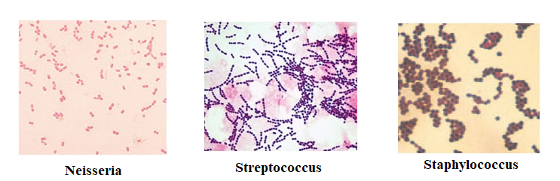
Fig 3.1: Detail of coccus
Bacilli:
Bacilli are rod shaped bacteria. Various bacilli may vary in length to width ratio. There are certain bacteria that are so short that they resemble coccus and are termed coccobacilli. The shape of the rod's end may be flat, cigar-shaped or circular. Some of the bacteria as distinctive curves and are known as vibrios. Some bacteria are shaped like long rods twisted into spirals or helices are called spirillum.
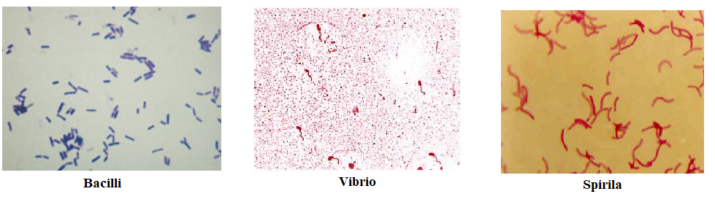
Fig 3.2: Detail of bacillus
Size of Bacteria:
Bacterial cells are found in a number of sizes. Smallest bacteria belonging to the genus Mycoplasma is only 0.3μm in diameter. Most bacterial size falls in the range of 1-5 μm. The largest bacterium is Thiomargarita namibiensis. These are generally 0.1 x 0.3 mm (100 x 300 μm) wide. The species was discovered by Heide N. Schulz and others in 1997, in the coastal sediments of Walvis Bay (Namibia).
Apart from cell structure and cell morphology certain other structures of cell can be identified and observed using light microscopy. Special staining techniques are employed to observe these structures. Most of the time, these staining techniques are called differential staining. Some examples of differential staining are:
Grams staining: differentiate gram negative and gram positive cells.
Endospore staining: to identify endospore. (An endospore is a non-reproductive, tough and dormant structure produced by certain bacteria. These structures are extraordinarily resistant to the environmental stresses such as ultraviolet radiation, gamma radiation, heat, chemical disinfectants, and desiccation.)
Materials:
- Microscope
- Specimen
- Simple staining dyes
- Slides
- Water beaker
Procedure:
- Clean and adjust the microscope carefully.
- Prepare the specimen by simple staining technique.
- Fix the smear slide under microscope.
- Notice and write observations of respective cells examined by microscope.
Study of Prokaryotic cell under microscope
Organisms having no well-defined nucleus are called prokaryotes. Examples are Monera or Bacteria and Archaea. Typical structure of a prokaryotic cell and its components observed under microscope are given in figure 1.
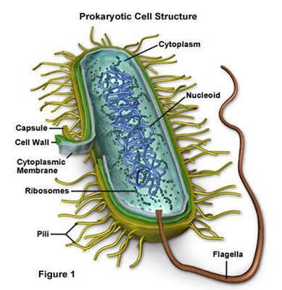
Figure 3.3: A typical structure of bacterial cell
Cell Wall
Provide shape and protection to cell.
Pilli
Organ for the exchange of genetic material from one bacterium to another
Capsule
Sticky projections that cover cell wall and provide protection from phagocytosis, chemicals and dehydration
Flagellum
A “whip-like;” structure that helps in movement
Plasma Membrane
A thin, flexible asymmetrical “sac” that holds the cytoplasm and serves as a passageway for anything that enters or leaves the cell such as nutrients and gases.
Cytoplasm
Contains organelles for different functions inside the cell
Nucleoid or Nuclear Body
Area of the cytoplasm where the DNA strand is located
Plasmids
Extra chromosomal piece of DNA, plasmids are often the site of genes that code for resistance to antibiotics.
Ribosomes
The function of prokaryotic ribosomes widely depends on the bacteria.

Practical No: 4 Study of Eukaryotic cell

Eukaryotic cells are cells that contain a nucleus and organelles, and are enclosed by a plasma membrane. Organisms that have eukaryotic cells include protozoa, fungi, plants and animals. These organisms are grouped into the biological domain Eukaryota. Eukaryotic cells are larger and more complex than prokaryotic cells, which are found in Archaea and Bacteria, the other two domains of life. Typical structures of Eukaryotic cells including plant and animal cell and its components are given below in figure 2.
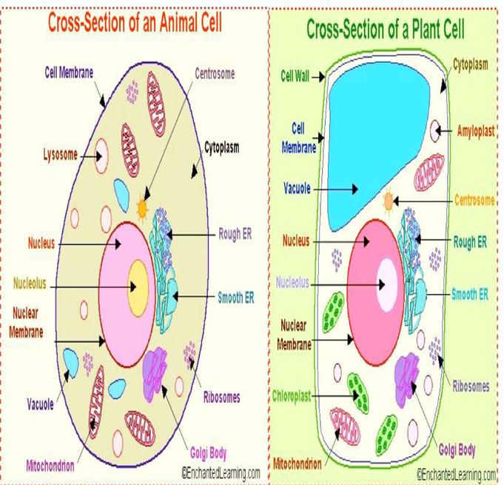
Figure 4.1: Representing a typical animal and plant cell
Characteristics of Eukaryotic Cells
Eukaryotic cells contain a variety of structures called organelles, which perform various functions within the cell. Examples of organelles are ribosomes, which make proteins, the endoplasmic reticulum, which sorts and packages the proteins, and mitochondria, which produce the energy molecule adenosine triphosphate (ATP). They also have a true nucleus, which contains the genetic material DNA and is surrounded by a nuclear envelope. All of the organelles are stabilized and given physical support through the cytoskeleton, which is also involved in sending signals from one part of the cell to the other. In eukaryotic cells, the cytoskeleton is composed mainly of three types of filaments: microtubules, microfilaments, and intermediate filaments. The gel-like substance that surrounds all the organelles in the cell is called cytosol.
Examples of Eukaryotic Cells
Plant Cells
Plant cells are unique among eukaryotic cells for several reasons. They have reinforced, relatively thick cell walls that are made mostly of cellulose and help maintain structural support in the plant. Each plant cell has a large vacuole in the center that allows it to maintain turgor pressure, which is pressure from having a lot of water in the cell and helps keep the plant upright. Plant cells also contain organelles called chloroplasts which contain the molecule chlorophyll. This important molecule is used in the process of photosynthesis, which is when a plant makes its own energy from sunlight, carbon dioxide, and water.
Fungal Cells
Like plant cells, fungal cells also have a cell wall, but their cell wall is made of chitin (the same substance found in insect exoskeletons). Some fungi have septa, which are holes that allow organelles and cytoplasm to pass between them. This makes the boundaries between different cells less clear.
Animal Cells
Animal cells do not have cell walls. Instead, they have only a plasma membrane. The lack of a cell wall allows animal cells to form many different shapes, and allows for the processes of phagocytosis “cell eating” and pinocytosis “cell drinking” to occur. Animal cells differ from plant cells in that they do not have chloroplasts and have smaller vacuoles instead of a large central vacuole.
Protozoa
Protozoa are eukaryotic organisms that consist of a single cell. They can move around and eat, and they digest food in vacuoles. Some protozoa have many cilia, which are small “arms” that allow them to move around. Some also have a thin layer called a pellicle, which provides support to the cell membrane.

Practical No: 5 Study of Plant cell

Plant cells are eukaryotic cells with a true nucleus along with specialized structures called organelles that carry out certain specific functions.
Structure of Plant Cell
The plant cell is rectangular and comparatively larger than the animal cell. Even though plant and animal cells are eukaryotic and share a few cell organelles, plant cells are quite distinct when compared to animal cell as they perform different functions. Some of these differences can be clearly understood when the cells are examined under an electron microscope.
Plant Cell Structure
Just like different organs within the body, plant cell structure includes various components known as cell organelles that perform different functions to sustain itself. These organelles include:
Cell Wall
It is a rigid layer which is composed of cellulose, glycoproteins, lignin, pectin, and hemicellulose. It is located outside the cell membrane. It comprises proteins, polysaccharides, and cellulose.
The primary function of the cell wall is to protect and provide structural support to the cell, to protect cell against mechanical stress and to provide form and structure to the cell. It also filters the molecules passing in and out of the cell.
Cell membrane
It is the semi-permeable membrane that is present within the cell wall. It is composed of a thin layer of protein and fat. The cell membrane plays an important role in regulating the entry and exit of specific substances within the cell.
Nucleus
The nucleus is a membrane-bound structure that is present only in eukaryotic cells. The vital function of a nucleus is to store DNA or hereditary information required for cell division, metabolism, and growth.
Mitochondria
Mitochondria are known as the powerhouses of the cell. The energy required for various chemical activities needed for life is released by mitochondria in the form of ATP (Adenosine triphopshate) molecules.

Plastids
Plastids are present only in plant cells. There are two types of plastids chromoplasts (colored plastids) and leucoplasts (white or colorless plastids).
Chloroplasts Plastids containing the pigment chlorophyll are known as chloroplasts. Chloroplasts are important for photosynthesis in plants. Chloroplasts also contain various yellow or orange pigments in addition to chlorophyll.
Leucoplasts are primarily organelles in which materials such as starch, oils and protein granules are stored.
Vacuoles
Vacuoles are storage sacs for solid or liquid contents. Vacuoles are small sized in animal cells while plant cells have very large vacuoles. The central vacuole of some plant cells may occupy 50-90% of the cell volume. In plant cells vacuoles are full of cell sap and provide turgidity and rigidity to the cell.
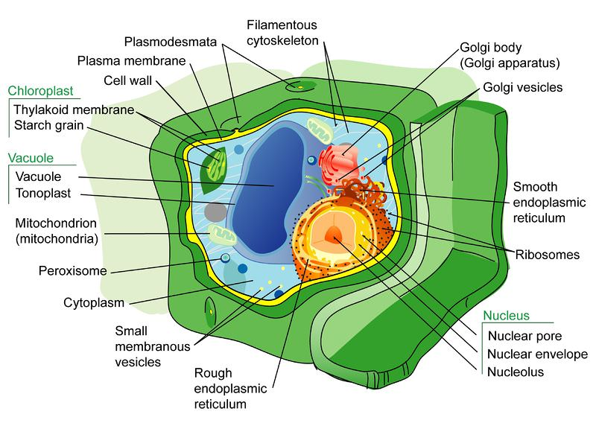
Figure 5.1: Structure a typical Plant cell

Practical No: 6 Study of Animal cell

Animals are a large group of diverse living organisms that make up to three-quarters of all species on earth. With their ability to move, to respond to stimuli, respond to environmental changes and adapt to different modes of feeding defense mechanisms and reproduction, all these mechanisms are enhanced by their constituent elements in the body. However, animals cannot manufacture their own food like plants and hence they depend on plants in one way or another. Animal cells and plant cells have similarities and differences. An animal cell does not have a fixed shape and cell wall whereas as a plant cell have a fixed shape and surrounded by a cell wall. Like a plant cell, an animal cell has a plasma membrane, cytoplasm and nucleus.
Animal cell size and shape
Animal cells come in all kinds of shapes and sizes, with their size ranging from a few millimeters to micrometers. The largest animal cell is the ostrich egg which has a 5-inch diameter, weighing about 1.2-1.4 kg and the smallest animal cells are the neurons of about 100 microns in diameter.
Animal cells are smaller than the plant cells and they are generally irregular in shape taking various forms of shapes, due to lack of the cell wall. Some cells are round, oval, flattened or rod-shaped, spherical, concave, rectangular.
Animal cell structure
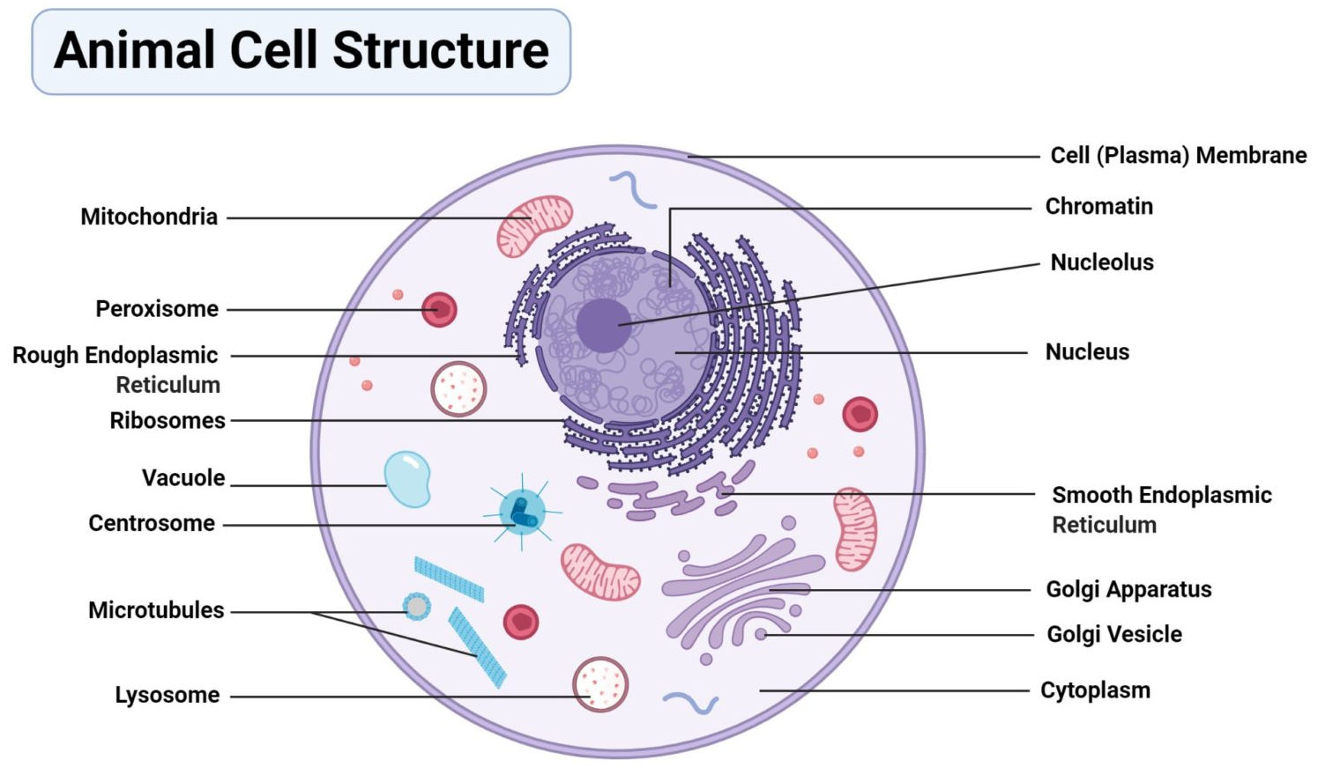
Fig 6.1: Detail of animal cell organelles
Nucleus
The nucleus contains all the genetic material in a cell. This genetic information is called deoxyribonucleic acid (DNA). DNA contains all the instructions for making proteins, which control all of the body’s activities. Therefore, the nucleus is like the manager’s office of the cell.
Ribosomes
Ribosomes are organelles found in both prokaryotic and eukaryotic cells. They are like mini machines that synthesize all the proteins in the cell. In any single animal cell, there can be as many as 10 million ribosomes.
Endoplasmic Reticulum
The endoplasmic reticulum (ER) is a network of flattened, membrane-bound sacs that are involved in the production, processing, and transport of proteins that have been synthesized by ribosomes. There are two kinds of endoplasmic reticulum: smooth and rough. The rough ER has ribosomes attached to the surface of the sacs. Smooth ER does not have ribosomes attached and has functions in storage, synthesizing lipids, removing toxic substances.
Golgi apparatus
The Golgi apparatus also called the Golgi complex or Golgi body, receives proteins from the ER and folds, sorts, and packages these proteins into vesicles.
Lysosomes
Lysosomes are a type of vesicle. Vesicles are spheres surrounded by a membrane that excludes their contents from the rest of the cytoplasm.
Mitochondria
Mitochondria are the energy-producing organelles, commonly known as “the powerhouse of the cell.” The process of cellular respiration occurs in the mitochondria. During this process, sugars and fats are broken down through a series of chemical reactions, releasing energy in the form of adenosine triphosphate (ATP).
Cytoplasm
The cytosol is the gel-like liquid contained within cells. The cytosol and all the organelles within it – except for the nucleus – are collectively referred to as the cell’s cytoplasm.
Cytoskeleton
The cytoskeleton is a network of filaments and tubules found throughout the cytoplasm of the cell. It has many functions: it gives the cell shape, provides strength, stabilizes tissues, anchors organelles within the cell, and has a role in cell signaling.
Cell Membrane
The cell membrane surrounds the entire cell and separates its components from the outer environment. The cell membrane is a double layer made up of phospholipids (called the phospholipid bilayer). Phospholipids are molecules with a phosphate group head attached to glycerol and two fatty acid tails. They spontaneously form double membranes in water due to the hydrophilic properties of the head and hydrophobic properties of the tails.
Experiment
Objective:
- To prepare slides of animal cell (Human epidermal cell)
- The inner part of your cheek is covered with skin cells called epidermal cells. These surfaces cells can be easily obtained for study
Procedure
- Gently rub the soft end of a cotton swab on the inner surface of your cheeks.
- Rub the end of the swab onto a clean glass slide
- Add a very small drop of methylene blue dye
- Allow the preparation to stand for one minute
- Cover the preparation with a cover slip
- Examine under low power, then medium and finally high power.
Observations
Draw what you have seen in the microscope as diagram and label cell membrane, nucleus and cytoplasm.
Table 6.1: Similarities and dissimilarities in plant and animal cell
Organelles | Plant Cell | Animal Cell
Cell Wall | Cell wall made of cellulose is present in  almost all cells | Cell wall is absent
Plastids | Plastids like leucoplasts, chloroplast and  chromoplasts are present | No plastids found
Chloroplasts | Plants cells have chloroplasts to prepare  their own food | Chloroplasts completely absent
Vacuoles | Cell sap containing vacuoles are present | Vacuoles are usually absent or one or more small vacuoles are
Lysosomes | Lysosomes not evident | Lysosomes occur in cytoplasm
Nucleus | Due to the presence of the vacuole at the center of the cell, nucleus may be located at the edge of the cell | Nucleus is usually located centrally
Golgi bodies | Plant cells have many simpler units of Golgi complex, called dictyosomes | Animal cells have a single highly  elaborate Golgi complex
Endoplasmic reticulum | Present | Present
Ribosomes | Present | Present
Mitochondria | Present | Present
Centrioles | Present only in lower plant forms. | Present

Practical No: 7 Cell structure in staminal hair of tradescantia

Tradescantia (a spiderwort) is an invasive species and is well known to show cytoplasmic movements. In an attempt to study the phenomenon of cyclosis, the purple-heart species (Tradescantia pallida) was selected.
Presence of staminal hair emerging from the base of the filaments is a characteristic feature of the plant. The staminal hair (also referred to as trichomes) had oval shaped cells arranged in a uniseriate manner. A screen-shot image of a magnified cell appeared amazing. The cells appeared like rosary beads. We tried to capture slight movement in the cells (on zooming), though not very clear.
To study cyclosis from Tradescantia stamina hair
Requirements: Tradescantia flowers, Microscope, Cover slip, Glass slide, brush and forceps
Theory: Cyclosis is automatic movement of protoplasm of a cell. This movement may be due to the movement of organelles like chloroplast in response to changing intensity of light. It is believed that cyclosis occurs due to Sol-gel interconversions or microfibrils.
Procedure:
1. Take fresh tradescantia flowers.
2. Staminal hairs remove and keep on clean glass slide with a drop of water.
3. Place a coverslip over sample and observe under microscope.
Precautions:
1. Flowers should be fresh
2. There should not be any air bubble
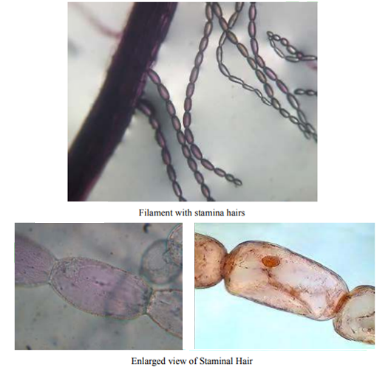
Fig 7.1: Study of cell structure in staminal hair of Tradescantia

Practical No: 8 Study of different types of Plastids

Introduction
Plastids are double membrane bound organelles found inside plants and some algae, which are primarily responsible for activities related to making and storing food. Many plastids are photosynthetic, but some are not. Some of the most common plastids include: chloroplasts, chromoplasts, gerontoplasts, and leucoplasts.
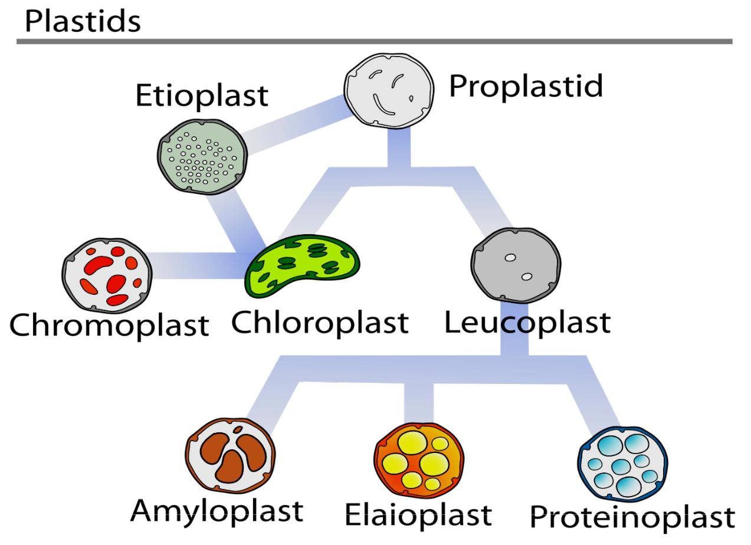

Fig 8.1: Some of the major types of plastids
Types and Functions
The chloroplasts are probably for the photosynthesis. The chloroplast most is known of filled with the plastids. These are responsible thylakoids and chlorophyll, where photosynthesis occurs.
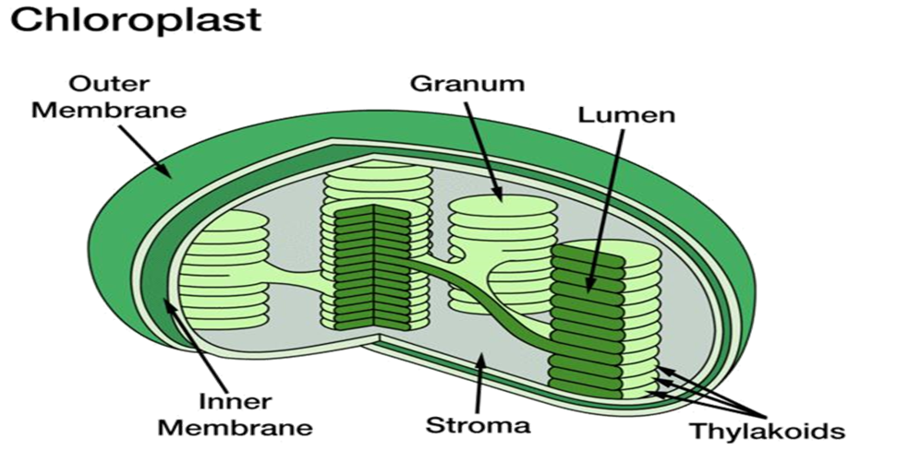
Fig 8.2: The basic structure of the chloroplast

Chromoplasts
These are found in flowering plants, fruits, and aging leaves. The chloroplasts actually convert over to chromoplasts. There are carotenoid pigments here that allow for the different colors you see in fruits and the fall leaves. One of the main reasons for these structures and the colors is to attract pollinators.
Gerontoplasts
They are basically chloroplasts that are going through the aging process. These are chloroplasts of the leaves that are beginning to convert into different organelles or are being repurposed since the leaf is no longer utilizing photosynthesis (such as in the fall months).
Leucoplasts
They are the non-pigmented organelles. Unlike the others we have talked about, leucoplasts have no color at all. They are found in the non-photosynthetic parts of the plant, such as the roots. Depending on what the plant needs, they may become essentially just storage sheds for starches, lipids, and proteins. They are more readily used for synthesizing amino acids and fatty acids. Leucoplasts are further subdivided into three different plastids: amyloplasts, proteinoplasts, and elaioplasts. Amyloplasts are the largest of the three and are charged with storing starch. Then there are the proteinoplasts that help to store the proteins that a plant needs and are typically found in seeds. Finally, the elaioplasts are used to store fats and oils that are needed by the plant especially in seeds.
Objective:
Observation of amyloplast from potato tuber
Observation of chromoplast from rose petal.
Observation of amyloplast from potato tuber
Materials:
- Potato tuber
- Razor blade
- Iodine stain
- Slides with cover slips
- Microscope2
Procedure:
- Make a thin section of potato tuber with the help of razor blade.
- Stain with iodine stain for a few seconds.
- Add cover slips on slides.
- Observe it under microscope
- The intensely stained structures in the cells are amyloplasts, a type of plastids that store starch.
Observation of chromoplast from rose petal
Materials:
- Rose petal
- Razor blade
- Water beaker
- Slides with cover slips
- Microscope
Procedure:
- Make a thin section of red pepper with the help of razor blade.
- Place the section in a drop of water on glass slide and add a cover slip.
- Examine it under the microscope.
- The tiny pinpoint orange organelles are chromoplasts, a type of plastid containing pigments other than chlorophyll.

Practical No: 9 Study of cellular reproduction

Introduction
Cell division is fundamental to all living organisms and required for growth and development. As an essential means of reproduction for all living things, cell division allows organisms to transfer their genetic material to their offspring. For a unicellular organism, cellular division generates a completely new organism. For multicellular organisms, cellular division produces new cells for the general development of the organism, as well as produces healthy cells to replace damaged cells from injury. Reproduction of multicellular organisms requires cell division to create reproductive cells.
Cell cycle
About 78% of a cell’s life is spent in Interphase, growing and preparing itself for cell division. Interphase itself contains three sub phases. Immediately after cell division, a newly-formed cell enters the Gap 1 or G1 portion of Interphase. During G1, cells actively grow and, in many cases, differentiate to perform specific functions. At this stage, the cell is sensitive to internal and external signals to determine whether to divide or not. Some cells, such as neurons do not proceed to cell division after differentiation and remain in G1 until they die. Once the cell meets criteria to proceed to cell division, it enters the synthesis or S stage of Interphase, during which the cell replicates its entire genome. Next, the cell enters the Gap 2 or G2 phase to synthesize all the necessary proteins for cell division. This is followed by the cell division phase.
Types of Cell Division in Eukaryotes
There are two types of cell division in eukaryotic cells—mitosis and meiosis.
Mitosis
In single-cell organisms, mitosis is the only form of cellular reproduction. One round of mitosis yields two genetically identical cells. In bacteria, this process results in an entirely new, independent organism. This is classified as asexual reproduction because it does not require sex for the creation of new organisms. In multi-cellular organisms, mitosis only occurs in somatic cells, which comprise all cells in an organism excluding germ cells.
Cells that undergo mitosis duplicate their chromosomes, resulting in cells with two times their normal haploid or diploid numbers (4Nchromosomes). Newly-synthesized chromosomes remain closely associated with their like-chromosome. These two identical chromosomes are called sister chromatids. Once duplicated, sister chromatids separate such that one copy of each chromosome lines up on opposite ends of the cell. The cell then pinches in the center until it breaks into two different cells. A nucleus then forms around the chromosomes in each cell to yield two cells with the same original number of chromosomes as the preexisting cell.

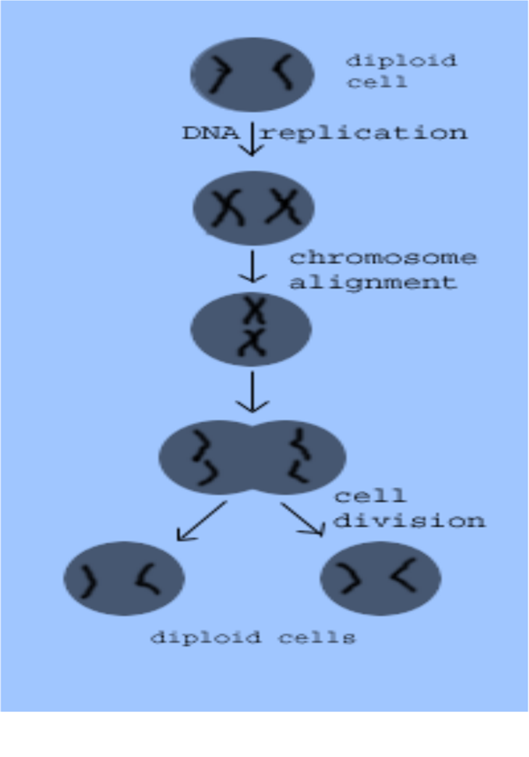
Fig 9.1.: Events of mitosis
Meiosis
There are two major differences between mitosis and meiosis. First, meiosis involves not one, but two cell divisions. Second, meiosis leads to the production of germ cells, which are cells that give rise to gametes. Germ cells are different from somatic cells in a critical way. Whereas somatic cells are diploid, meaning they have two copies of each chromosome, germ cells are haploid. The haploid nature of germ cells is vital to the process of sexual reproduction.
There are two different sex cells or gametes: sperm and eggs. Males produce sperm and females produce eggs. Because they are produced from germ cells, gametes are likewise haploid. In order to create a new individual via sexual reproduction, a sperm cell needs to activate an egg by joining it in a fertilization process. When these two haploid cells unite, a diploid cell resulted. This specialized cell can then develop into a new individual. The sexual reproductive process just described ensures that the resulting offspring will have an equal maternal and paternal genetic contribution.
As we mentioned earlier, higher-order cells contain homologous pairs of chromosomes--one from the father and the other from the mother. In meiosis, as in mitosis, the maternal and paternal homologues are replicated during DNA replication yielding two pairs of sister chromatids. After the first cell division, each of the resulting cells contains a pair of sister chromatids—-one maternal pair and the other paternal. Unlike mitosis, meiosis does not end after one division; it continues with a second cell division. In this division, the sister chromatids are separated yielding four total haploid cells.

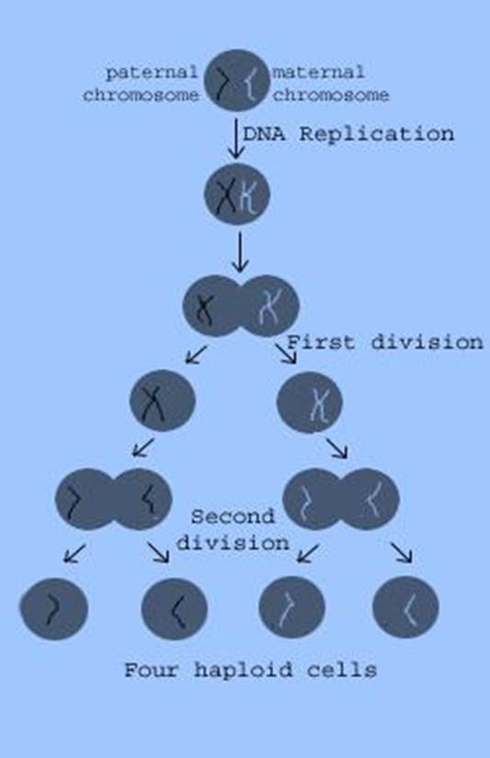
Figure 9.2: Events of meiosis

Practical No: 10 Study of Mitosis

In cell biology, mitosis is a part of the cell cycle when replicated chromosomes are separated into two new nuclei. Cell division gives rise to genetically identical cells in which the number of chromosomes is maintained. In general, mitosis (division of the nucleus) is preceded by the S stage of interphase (during which the DNA is replicated) and is often accompanied or followed by cytokinesis, which divides the cytoplasm, organelles and cell membrane into two new cells containing roughly equal shares of these cellular components. Mitosis and cytokinesis together define the mitotic (M) phase of an animal cell cycle—the division of the mother cell into two daughter cells genetically identical to each other.
In mitosis, the nucleus of the Eukaryotic cells divides into two, subsequently resulting in the splitting of the parent cells into two daughter cells. Hence, every cell division involves two chief stages:
Cytokinesis – Cytoplasm division
Karyokinesis – Nucleus division
Stages of Mitosis
The various stages of mitosis are:
1. Prophase
The process of mitosis is initiated at this stage wherein coiling and thickening of the chromosomes occurs. Shrinking and hence the disappearance of the nucleolus and nuclear membrane takes place. The stage reaches its final state when a cluster of fibers organizes to form the spindle fibers.
2. Metaphase
Chromosomes turn thick in this phase. The two chromatids from each of the chromosomes appear distinct. Each of the chromosomes is fastened to the spindle fibers located on its controller. Chromosomes align at the centerline of the cell
3. Anaphase
Each of the chromatid pair detaches from the centromere and approaches the other end of the cell through the spindle fiber. At this stage, compressing of the cell membrane at the center takes place
4. Telophase
Chromatids have reached the other end of the cell. The disappearance of the spindles. Chromatin fibers are formed as a result of uncoiling of daughter chromosomes. The appearance of two daughter nuclei at the opposing ends due to the reformation of the nucleolus and nuclear membrane. At this phase, splitting of the cell or cytokinesis may also occur. Post mitosis, the next stage is referred to as interphase which is part of the cell cycle that is non-dividing and between two consecutive cell divisions. A cell spends most of its life in the interphase. It comprises the G1, S and G2 stages.

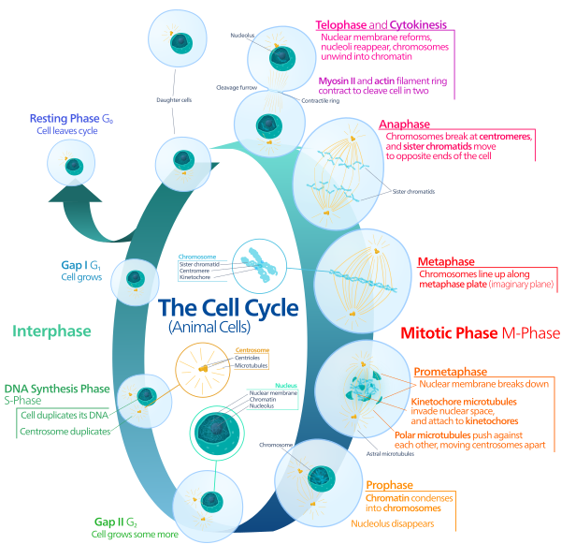
Fig 10.2: Detail of animal cell cycle

Study of the Stages of Mitosis from Permanent Slides
Objectives
In today’s lab, you will first observe prepared slides animal cells in different stages of cell division. In the second part of the lab, you will prepare your own slides of onion root tips and examine the tissue for both interphase and mitotic cells. By the end of today’s lab, you should be able to:
- Use a microscope to identify cells in interphase and different stages of mitosis from prepared slides.
- Prepare your own temporary mounts of onion root tips and examine them under the microscope for different phases of the cell cycle in practical 12.
Materials Required
- Permanent slides of mitosis
- Compound Microscope
Study
The teacher will place some permanent slides on the stage of compound microscope and ask the students to observe and identify the stages of mitosis.
1. Prophase: In this slide some chromosomes are seen; the chromosomes are long and scattered. No spindle fiber is seen. Therefore the stage is Prophase of Mitosis.
2. Pro-Metaphase: In this slide some chromosomes are seen. Spindleapparatus is also seen. The chromosomes are seemed to moving towards equatorial plane. The chromosomes are divided into chromatids. Therefore this is the Pro-Metaphase of Mitosis.
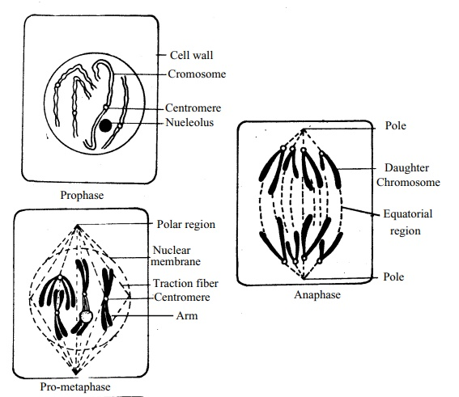
Fig 10.2: Slides detail of cell cycle
3. Metaphase: Some chromosomes are seen in this slide. Spindle apparatus is seen here. The chromosomes are situated on the equatorial zone. The chromosomes are divided into chromatids. Therefore this is the Metaphaseof Mitosis.
4. Anaphase: In this slide two sets of chromosomes are seen. Two sets arepresent near the two poles. Therefore it is the Anaphase of Mitosis.
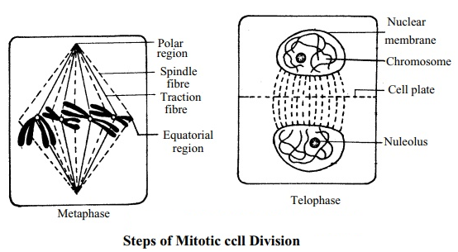
Fig 10.3: Slides detail of cell cycle
5. Telophase: In this slide two sets of chromosomes are seen. Two sets of chromosomes are present at two poles. No spindle apparatus is seen. Nuclear membrane is present surrounding the chromosomes in each pole. Therefore it is the Telophase of Mitosis.

Practical No: 11 Study of Meiosis

Meiosis is a process where a single cell divides twice to produce four cells containing half the original amount of genetic information. These cells are our sex cells – sperm in males, eggs in females. During meiosis one cell divides twice to form four daughter cells. These four daughter cells only have half the number of chromosomes of the parent cell – they are haploid. Meiosis produces our sex cells or gametes (eggs in females and sperm in males).
Meiosis can be divided into nine stages. These are divided between the first time the cell divides (meiosis I) and the second time it divides (meiosis II):
Meiosis I
1. Interphase
The DNA in the cell is copied resulting in two identical full sets of chromosomes.
Outside of the nucleus are two centrosomes, each containing a pair of centrioles, these structures are critical for the process of cell division.
During interphase, microtubules extend from these centrosomes.
2. Prophase I
The copied chromosomes condense into X-shaped structures that can be easily seen under a microscope. Each chromosome is composed of two sister chromatids containing identical genetic information. The chromosomes pair up so that both copies of chromosome 1 are together; both copies of chromosome 2 are together, and so on. The pairs of chromosomes may then exchange bits of DNA in a process called recombination or crossing over. At the end of Prophase I the membrane around the nucleus in the cell dissolves away, releasing the chromosomes. The meiotic spindle, consisting of microtubules and other proteins, extends across the cell between the centrioles.
3. Metaphase I
The chromosome pairs line up next to each other along the center (equator) of the cell.
The centrioles are now at opposites poles of the cell with the meiotic spindles extending from them. The meiotic spindle fibers attach to one chromosome of each pair.
4. Anaphase I
The pair of chromosomes is then pulled apart by the meiotic spindle, which pulls one chromosome to one pole of the cell and the other chromosome to the opposite pole.
In meiosis I the sister chromatids stay together. This is different to what happens in mitosis and meiosis II.
5. Telophase I and cytokinesis
The chromosomes complete their move to the opposite poles of the cell.
At each pole of the cell a full set of chromosomes gather together.
A membrane forms around each set of chromosomes to create two new nuclei.
The single cell then pinches in the middle to form two separate daughter cells each containing a full set of chromosomes within a nucleus. This process is known as cytokinesis.
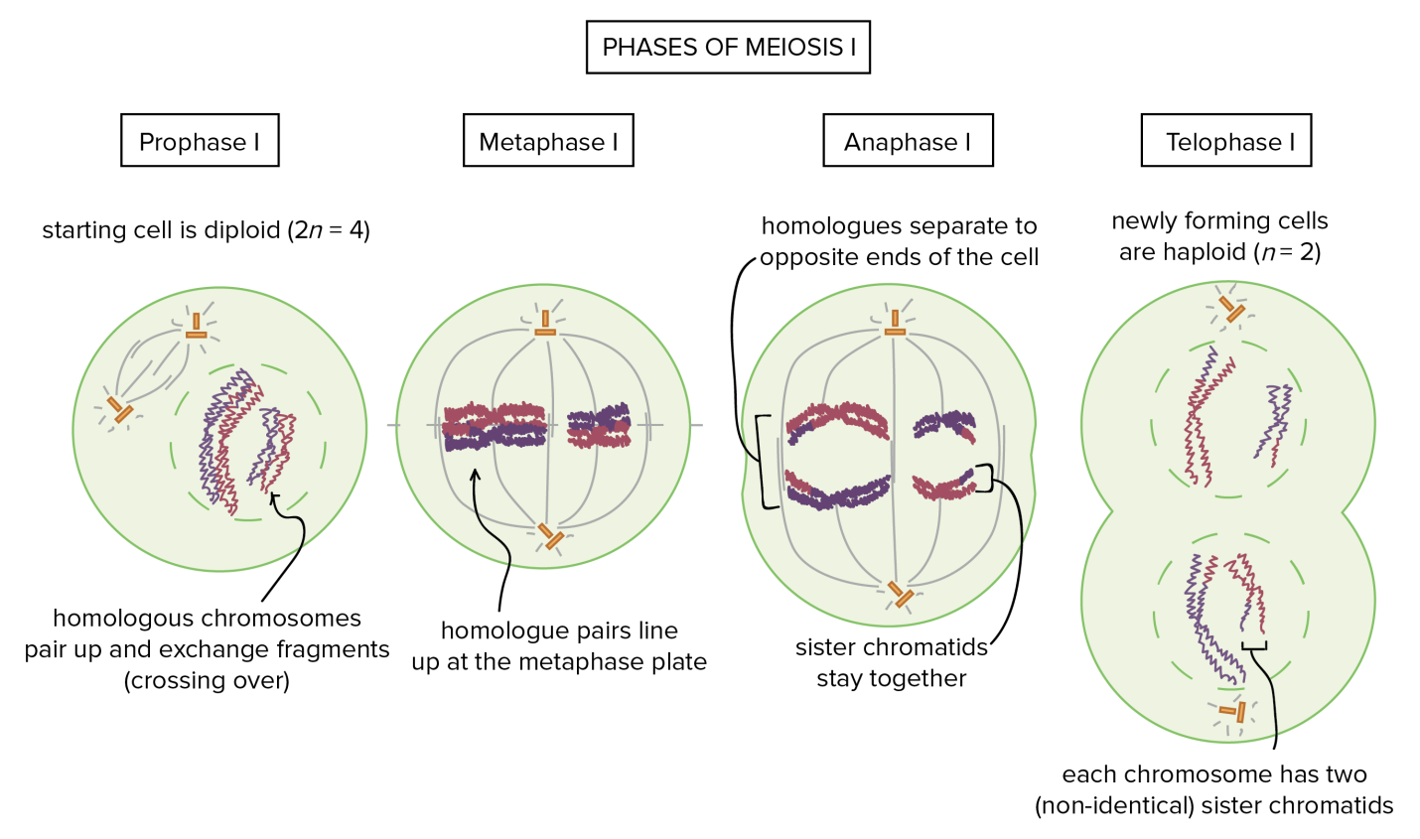
Fig 11.1: Stages of Meiosis I
Meiosis II
6. Prophase II
Now there are two daughter cells, each with 23 chromosomes (23 pairs of chromatids). In each of the two daughter cells the chromosomes condense again into visible X-shaped structures that can be easily seen under a microscope. The membrane around the nucleus in each daughter cell dissolves away releasing the chromosomes. The centrioles duplicate. The meiotic spindle forms again.
7. Metaphase II
In each of the two daughter cells the chromosomes (pair of sister chromatids) line up end-to-end along the equator of the cell. The centrioles are now at opposites poles in each of the daughter cells. Meiotic spindle fibres at each pole of the cell attach to each of the sister chromatids.
8. Anaphase II
The sister chromatids are then pulled to opposite poles due to the action of the meiotic spindle. The separated chromatids are now individual chromosomes.
9. Telophase II and cytokinesis
The chromosomes complete their move to the opposite poles of the cell. At each pole of the cell a full set of chromosomes gather together. A membrane forms around each set of chromosomes to create two new cell nuclei. This is the last phase of meiosis, however cell division is not complete without another round of cytokinesis. Once cytokinesis is complete there are four granddaughter cells, each with half a set of chromosomes (haploid): in males, these four cells are all sperm cells in females, one of the cells is an egg cell while the other three are polar bodies (small cells that do not develop into eggs).
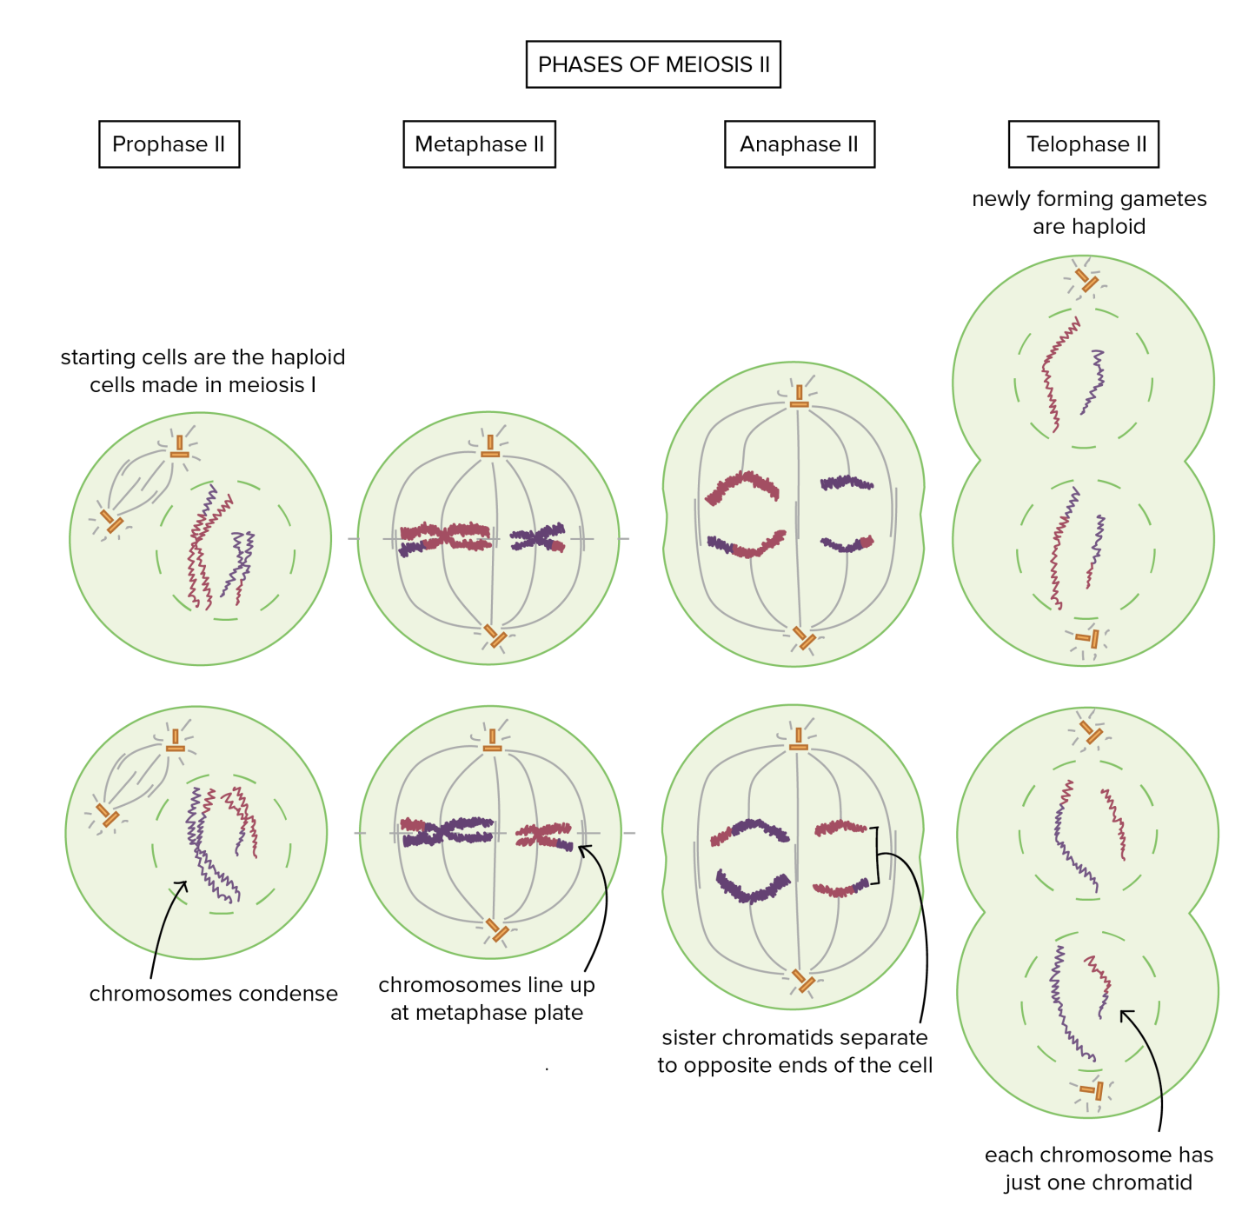
Fig 11.2: Stages of Meiosis II

Study of the Stages of Meiosis from Permanent Slides
Objectives
In today’s lab, you will first observe prepared slides animal cells in different stages of cell division. In the second part of the lab, you will prepare your own slides of onion root tips and examine the tissue for both interphase and meiotic cells. By the end of today’s lab, you should be able to:
- Use a microscope to identify cells in interphase and different stages of meiosis from prepared slides.
Materials Required
- Permanent slides of meiosis
- Compound Microscope

Practical No: 12 Mitosis: smear/squash preparation of onion roots

A quick overview of cell division
The genetic information of plants, animals and other eukaryotic organisms resides in several (or many) individual DNA molecules, or chromosomes. For example, each human cell possesses 46 chromosomes, while each cell of an onion possesses 8 chromosomes. All cells must replicate their DNA when dividing. During DNA replication, the two strands of the DNA double helix separate, and for each original strand a new complementary strand is produced, yielding two identical DNA molecules. DNA replication yields an identical pair of DNA molecules (called sister chromatids) attached at a region called the centromere. DNA replication in eukaryotes is followed by the process called mitosis which assures that each daughter cell receives one copy of each of the replicated chromosomes. During the process of mitosis, the chromosomes pass through several stages known as prophase, metaphase, anaphase and telophase. The actual division of the cytoplasm is called cytokinesis and occurs during telophase. During each of the preceding stages, particular events occur that contribute to the orderly distribution of the replicated chromosomes prior to cytokinesis.
Objective
Better understand the process and stages of mitosis.
Prepare your own specimens of onion root in which you can visualize all of the stages of mitosis.
Observation of mitosis in onion root tips
Roots and stems grow from their tips. Actively dividing tissues such as meristem are good sources of mitotically dividing cells. You will prepare squashes of onion root tip (Allium cepa) and observe cells in various stages of mitosis.
Why use onion roots for viewing mitosis?
- The roots are easy to grow in large numbers.
- The cells at the tip of the roots are actively dividing, and thus many cells will be in stages of mitosis.
- The tips can be prepared in a way that allows them to be flattened on microscopes slide (“squashed”) so that the chromosomes of individual cells can be observed.
- The chromosomes can be stained to make them more easily observable.
Regions of Onion Root tips
- There are three cellular regions near the tip of an onion root.
- The root cap contains cells that cover and protect the underlying growth region as the root pushed through the soil.
- The region of cell division (or meristem) is where cells are actively dividing but not increasing significantly in size.
- In the region of cell elongation, cell are increasing in size, but not dividing.

Materials:
- Onion plant with root
- Acetocarmine stain
- Scissors
- Forceps
- Razor blade
- Pasture pipette
- 1.5 ml Centrifuge tubes
- Dissection probe with wooden back
- Microscopic slides and cover slips
- Water bath
- Light Microscope
Procedure for preparing root tip squashes
While actively growing onions are present in the lab for you to observe, you will be provided with roots that have been previously harvested and treated with a fixative to stabilize the cells. You will work in groups for this lab exercise.
The first step will be to ‘soften’ the roots so that they later can be spread on a microscope slide.
1. Using scissors, cut 2 roots tips about 1 cm long, and transfer them into a plastic micro-tube. (One of the rots will be an extra one.)
2. Fill the tube about 2/3 full with 1N HCl from a dropper bottle.
Caution: Work with the HCl carefully, it is a strong acid.
3. Place the tube in a 60OC water bath, and allow the roots to incubate for 12 minutes.
4. After the 12 minute incubation period, remove the tube from the water bath.
Rinse the roots in H2O
1. Using forceps, carefully transfer the root tips to a small petri plate.
2. Using a plastic ‘squeeze’ pipet, carefully remove the HCl from the micro-tube and transfer it to the “discard flask”.
3. Rinse the root tips 3 times with water from the dropper bottle, disposing of the rinses in the discard flask.
Staining the chromosomes
1. After removing the water from the third rinse, cover the root with the Feulgen stain. Caution: Although the Feulgen stain does not appear colored, it will strongly stain skin and clothing.
2. Incubate the roots in the stain for 12 minutes. During this time the very tip of the root will begin to turn red as the DNA stains the numerous small actively dividing cells at the tip.
Remove the stain and again rinse the roots
1. Using a plastic ‘squeeze’ pipet, carefully remove the Feulgen stain and discard it in the discard flask.
2. Again, rinse the root tips 3 times with water.
Preparing the root tip squash
1. Transfer a root to the center of a clean microscope slide and add a drop of water.
2. Using a razor blade cut off most of the unstained part of the root, and discards it.
3. Cover the root tip with a cover slip, and then carefully push down on the cover slide with the wooden end of a dissecting probe. Push hard, but do not twist or push the cover slide sideways. The root tip should spread out to a diameter about 0.5 – 1 cm.
Observations of onion root tip squash:
Scan the microscope under the 10x objective. Look for the region that has large nuclei relative to the size of the cell; among these cells will be found cells displaying stages of mitosis. Examples are shown in the figure to the right. Switch to the 40X objective to make closer observations. Since prophase and Prometaphase are difficult to distinguish, classify all these cells as prophase. Record your observations in the table provided.
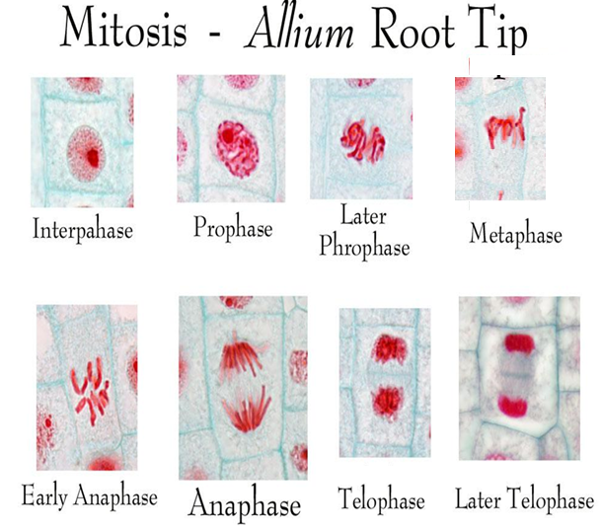
Fig 12.1: Detail of Mitosis

References:
- http://www.tutorvista.com/biology/microscope-parts-and-functions
- http://www.microrao.com/simple_staining.htm
- https://www.boundless.com/microbiology/textbooks/boundless-microbiology-textbook/microscopy-3/light-microscopy-29/general-staining-methods-243-4284/
- http://www.cliffsnotes.com/study-guides/biology/microbiology/microscopy/staining-techniques.
- http://vlab.amrita.edu/?sub=3&brch=73&sim=208&cnt=2
- http://www.microscopemaster.com/prokaryotes.html
- http://biology.tutorvista.com/animal-and-plant-cells.html
- http://www.cliffsnotes.com/study-guides/biology/biology/the-biology-of-cells/ prokaryote –and -eukaryote-cell-structure
- http://w3.marietta.edu/~biol/introlab/Onion%20root%20mitosis.pdf
- Campbell, N.A. and J.B. Reece. 2005. Biology, Seventh Edition. Benjamin Cummings, San Francisco, CA.
- http://www.biology4friends.org/cell-cycle-timing-lab1.html
- http://vlab.amrita.edu/?sub=3&brch=188&sim=1102&cnt=2
- http://sites.fas.harvard.edu/~bs50/Mit%20Mei%20Notebook.pdf
- http://www.sparknotes.com/biology/cellreproduction/intro/section2.rhtml
- http://vlab.amrita.edu/?sub=3&brch=188&sim=1102&cnt=2
- http://study.com/academy/lesson/plastids-definition-structure-types-functions.html
- http://faculty.valenciacollege.edu/tklenk/botany/labs/The%20Cell.htm
- http://www.uq.edu.au/_School_Science_Lessons/UNBiol1.html#9.9.1

